Pipetting Skills Test – How Good Are You?
07.05.2015qPCR Tips, Standard Posts
12 must-read tips to improve your pipetting technique. How many of these crucial steps have you already mastered and are a part of your pipetting routine?
When was the last time you thought about your pipetting technique after you first learned about it? For many of us pipetting becomes routine after a little practice. Typically, liquid handling quality assurance regulations place great emphasis on pipette calibration, repair and maintenance. However, ensuring the competence of the pipette operator (a lab employee) is an often neglected and altogether crucial area. In reality even highly experienced laboratory technologists may have never received formal pipetting training and may be prone to routine errors.
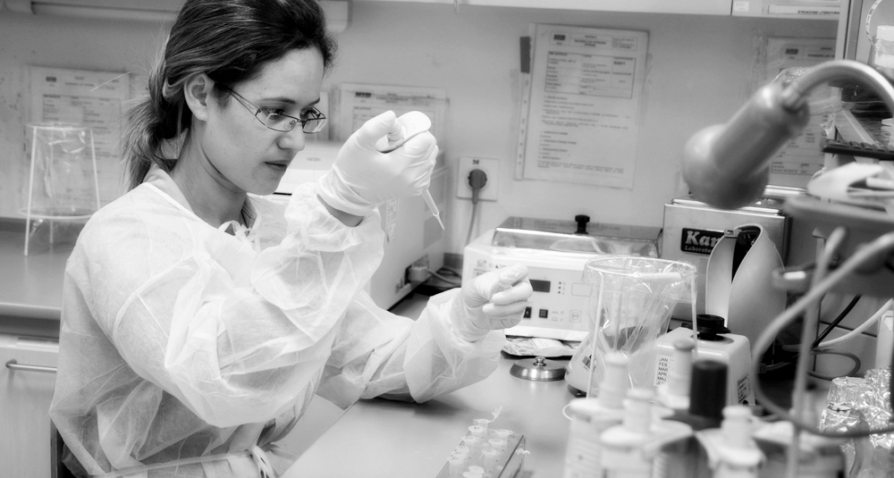
As your laboratory’s demand for accuracy and precision increases, so too does the importance of understanding and developing an optimal pipetting technique. Check below to see if there is still some room for improvement in your pipetting technique and give some consideration to these steps the next time you are pipetting:
HOW GOOD ARE YOU?
1. Pre-wet the pipette tip
Aspirate and expel any sample liquid at least three times before aspirating a sample for delivery. Evaporation within the tip can cause significant sample loss before delivery. Pre-wetting increases humidity within the tip thus reducing any variation in sample evaporation. Using the same tip (without pre-wetting) to deliver multiple samples can result in a lower volume for the first few samples. The need to pre-wet increases when working with volatile samples (i.e. organic solvents).
2. Immerse the tip to the proper depth during aspiration
Before aspirating, immerse the tip adequately below the meniscus. Large volume pipettes (1-5 mL) should be immersed to 5-6 mm, while smaller volume pipettes should be immersed to 2-3 mm. Too little immersion, particularly with large volume pipettes, can lead to air aspiration. Too much immersion can cause samples to cling to the outside of the tip. Touching the container bottom with the tip may restrict aspiration.
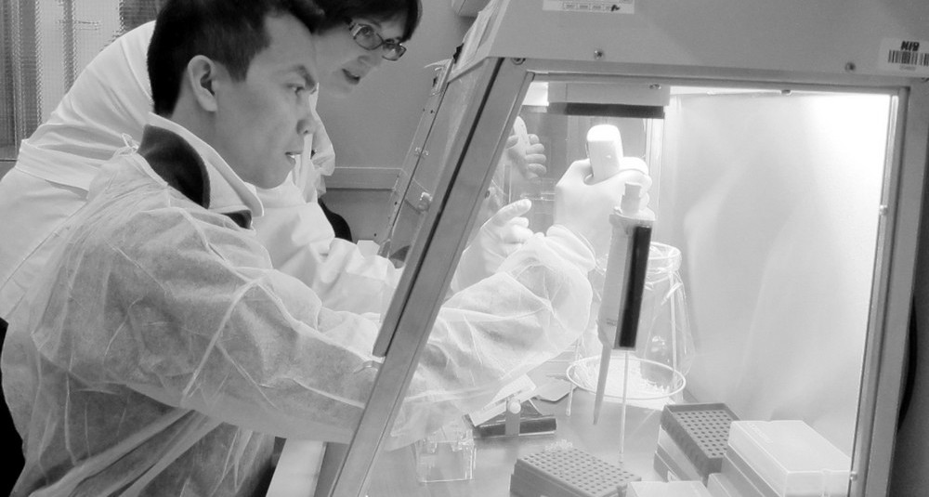
3. Pause consistently after aspiration
Pause with the tip in the liquid for about one second after aspirating the sample. It takes a moment for the liquid in the tip to finish moving after the plunger stops, so failure to pause will cause the volume to be too low. Make this pause as consistent as possible.
4. Use consistent plunger pressure and speed
Depress and release the plunger smoothly and with consistent pressure and speed when aspirating and dispensing each sample. Repeatable actions produce repeatable results.
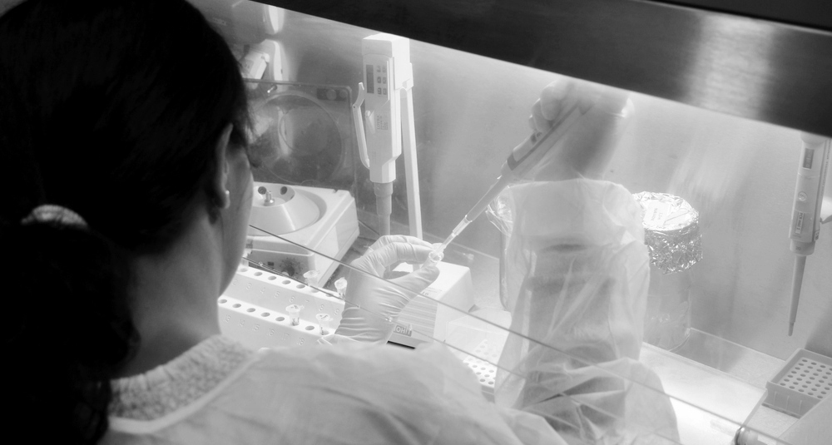
5. Pull the pipette straight out
During sample aspiration always hold the pipette vertically and avoid touching the sides of the container. After sample aspiration pull the pipette straight out of the liquid from the centre of the container. This technique is especially important when pipetting small volumes (<50µL). Holding the pipette at an angle as it is removed from the sample also alters the volume aspirated. Touching the sides of the container can cause wicking and a loss of volume because of surface tension effects.
6. Examine the tip before dispensing a sample
Before dispensing, carefully remove droplets on the outside of the tip with a lint-free cloth, being sure to stay clear of the tip opening to avoid the sample wicking out of the tip. Absorbent material rapidly carries a sample from the tip if it contacts the tip opening, therefore unnecessary tip wiping increases the possibility of sample loss.
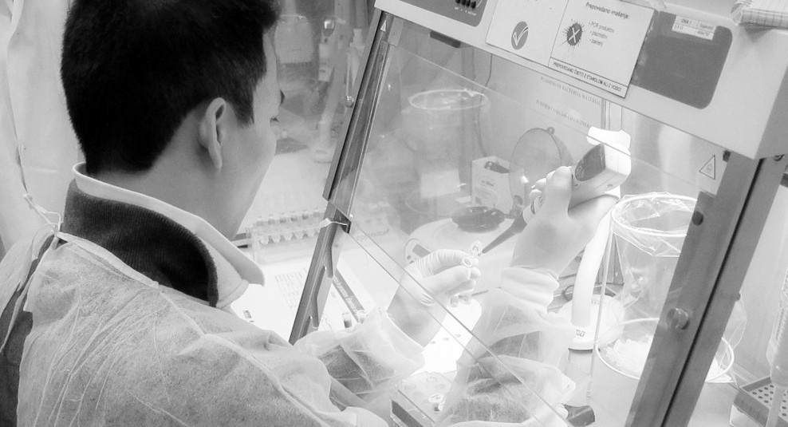
7. Examine the tip after dispensing a sample
While dispensing a sample, position the tip so that it touches the side of the container to deliver any residual sample remaining in the tip. Keeping your thumb on the second stop of the plunger, remove the tip to avoid sample re-aspiration into the pipette tip. Be certain that you see the sample leaving the tip.
8. Use standard mode pipetting
Choose “standard (or forward) mode” pipetting rather than “reverse mode” for all aqueous samples, but not for viscous or volatile samples. If the reverse mode is used with normal aqueous samples, the pipette tends to deliver more than the calibrated volume. On the other hand, using the standard mode with viscous or volatile samples may result in under-delivery.
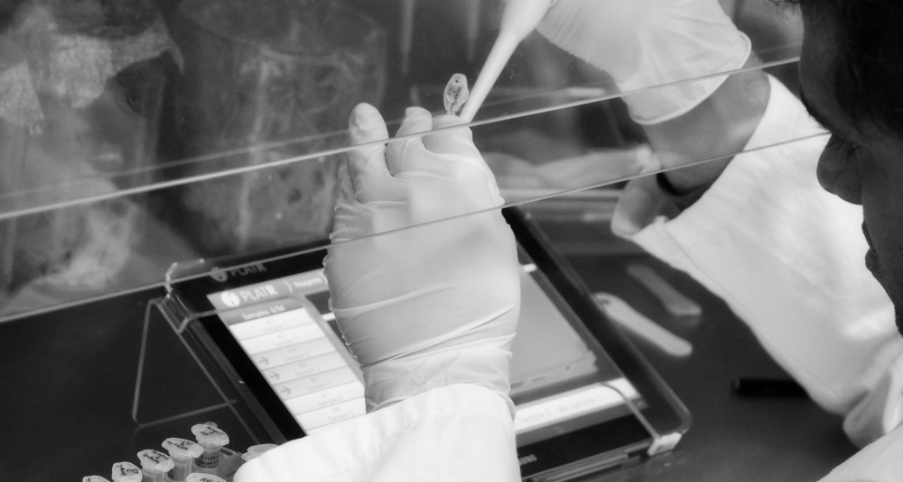
9. Use the appropriate pipette
It is important to use a pipette with a volume selection closest to the volume you plan to aspirate and dispense. The accuracy of your test will improve if there is a small difference between a pipette’s minimum volume and the volume being tested. For example, if you need to dispense 15 µL, a 1 mL pipette would be the wrong choice, whereas a 20 µL pipette would be ideal.
10. Use the correct pipette tip
Use high quality tips intended for use with specific pipettes. In most cases, manufacturer tips perform well. Alternative brands are also acceptable if their performance has been proven with a specific pipette model. Mismatched tips and pipettes can result in inaccuracy, imprecision, or both. Quality tips provide an airtight seal without the need for excessive force, are made of superior materials and are free of molding defects, thus ensuring dependable liquid delivery.
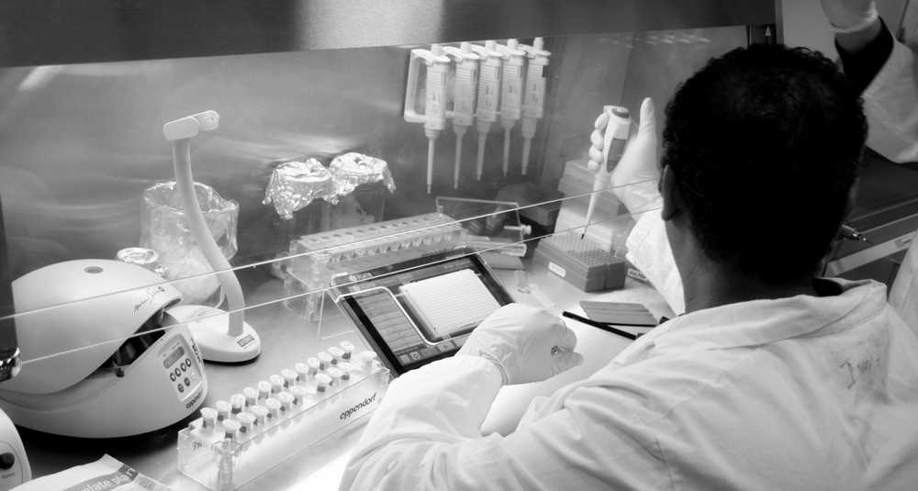
11. Work at ambient temperature equilibrium
Allow liquids and equipment to achieve equilibrium at an ambient temperature before you begin pipetting. The volume of a sample delivered by air displacement pipettes varies with air pressure, relative humidity and a liquid’s vapor pressure, all of which are temperature dependent. Working at a single, constant temperature minimizes this variation.
12. Minimize pipette handling
Hold the pipette loosely, return it to the pipette stand or set it down while you are not pipetting and wear gloves to reduce body heat transfer to equipment. Also avoid handling pipette tips, or containers of samples yet to be pipetted. Body heat transferred during handling disturbs temperature equilibrium, which can lead to variations in delivered volumes.
References:
http://www.artel-usa.com/wp-content/uploads/2013/09/Five-Good-Reasons-The-Argument-for-Pipetting-Technique-Training.pdf
http://www.artel-usa.com/resource-library/10-tips-to-improve-your-pipetting-technique/
http://www.shoreline.edu/biotechnology/outreach/documents/v2012-07-01_Lab1.pdf
https://www.anachem.co.uk/pipetting_techniques/how_to_pipette
http://www.qualitydigest.com/inside/metrology-article/how-improve-pipetting-technique
http://www.pipette.com/public/staticpages/guidetopipetting.aspx
http://www.ttelaboratories.com/Accuracy-Matters-Blog/entryid/25/10-ways-to-prevent-pipetting-errors
By Urska Cepin, Research and Development Assistant, BioSistemika LLC

